**PUBLIC TRANSPORT OPTIMIZATION USING IOT**

**PROJECT DESCRIPTION:**

By optimizing your public transport systems you can help citizens get where they’re going more quickly by reducing congestion on roadways and intelligently allocating and routing buses to areas with more travelers. That means locals, visitors and workers spend less time in transit and more time enjoying your city, successfully completing errands or getting to and from work. public transport may be the most important element of smart city planning because it affects everyone. All citizens and visitors need to get from one place to another, quickly and safely, and in today’s densely populated cities that means public transport.

**CIRCUIT DIAGRAM:**

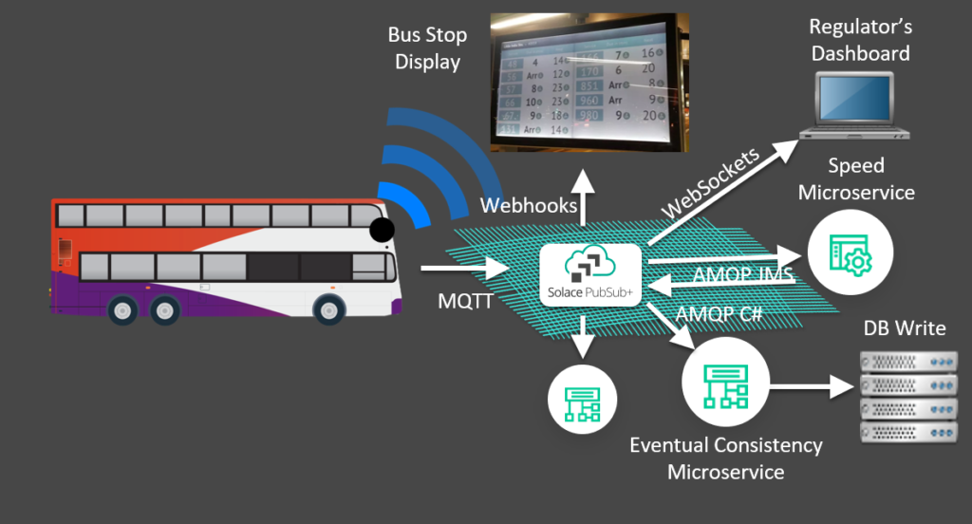

**Define Transportation Network:** The optimization process begins with defining the public transportation network, including routes, stops, and other relevant information.  
**Collect Data:** Gather data related to transportation, such as historical demand patterns, vehicle capacities, and travel times.  
**Preprocess Data:** Clean and format the data to make it suitable for use in optimization models.  
**Create Optimization Model:** Develop mathematical or computational models that represent the transportation network and optimization objectives, such as minimizing costs or maximizing efficiency.  
**Solve Optimization Problem:** Use optimization algorithms and software to solve the mathematical model and find optimal solutions.  
**Generate Optimal Routes and Schedules:** Obtain the optimal routes and schedules for vehicles based on the optimization results.  
**Implement Results in Transportation System:** Integrate the optimized routes and schedules into the transportation system, updating routes and dispatching vehicles accordingly.  
**Monitor and Adjust in Real-Time:** Continuously monitor the transportation system in real-time, making adjustments as needed to account for changing conditions and demand.  
**End:** The optimization process continues as an ongoing cycle, adapting to changes and improvements in the transportation system.

**Components of a Public Transportation Optimization Prototype:**

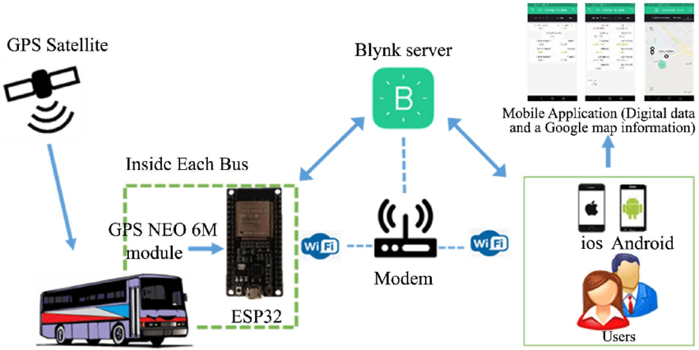

**1. Data Collection and Integration:**   - Gather data on routes, schedules, stops, vehicle capacity, passenger demand, historical travel times, and real-time traffic conditions.  
   - Integrate data from multiple sources, including GPS sensors, ticketing systems, and historical records.  
  
**2. Route Planning:**  
   - Create a representation of the transportation network, including routes, stops, and transfer points.  
   - Develop algorithms to optimize routes and schedules, considering factors like passenger demand, vehicle capacity, and traffic conditions.  
  
**3. Scheduling:**   - Design scheduling algorithms to allocate vehicles to routes and time slots efficiently.  
   - Consider constraints such as vehicle availability, driver schedules, and maintenance requirements.  
  
**4. Demand Forecasting:**  
   - Implement demand forecasting models to predict passenger demand at different times and locations.  
   - Use historical data and machine learning techniques for more accurate forecasts.  
  
**5. Real-Time Tracking and Monitoring:**  
   - Integrate GPS data from vehicles to track their real-time locations and movements.  
   - Implement a monitoring system to detect and respond to deviations from the planned schedule.  
  
**6. User Interface:**   - Create a user interface for transportation operators to input data, monitor the system, and make manual adjustments.  
   - Develop a passenger-facing interface to provide real-time information on routes, schedules, and arrival times.  
  
**7. Optimization Engine:**   - Build the core optimization engine that takes input data and produces optimized routes and schedules.  
   - Use optimization techniques such as linear programming, genetic algorithms, or heuristic methods.  
  
**8. Simulation and Testing:**   - Develop a simulation environment to test the system's performance under different scenarios.  
   - Conduct thorough testing and validation to ensure the system meets optimization goals.  
  
**9. Reporting and Analytics:**   - Implement reporting tools to generate performance metrics, including on-time performance, vehicle utilization, and cost savings.  
   - Use data analytics to identify areas for improvement and optimization.  
  
**10. Deployment and Integration:**  
    - Deploy the prototype in a controlled environment (e.g., a pilot city or transportation network).  
    - Integrate the prototype with existing transportation systems and infrastructure.  
  
**11. Scalability and Maintenance:**    - Design the prototype with scalability in mind to handle larger transportation networks.  
    - Establish a maintenance plan to keep the system running smoothly and up-to-date.  
  
**12. Documentation and Training:**    - Document the system's architecture, components, and algorithms.  
    - Provide training to transportation operators and administrators on how to use and maintain the system.  
  
Building a prototype for public transportation optimization is a complex and interdisciplinary task that often requires a team of engineers, data scientists, and domain experts. The choice of technologies, algorithms, and tools will depend on the specific requirements and constraints of the transportation network being optimized.

**App Development:**  
Build the app's frontend, implementing the designed UI and user interaction. Develop features such as route planning, real-time tracking, data visualization, and predictive algorithms

**Iot Implememtation:**

The project's core principle involves integrating IoT sensors into public transportation vehicles to revolutionize the efficiency and quality of public transit services. These sensors, including GPS and passenger counters, continuously gather real-time data. This data is then transmitted wirelessly to a central platform, where Python scripts process it. Passenger counts are aggregated, GPS data is analyzed for location and speed, and environmental conditions are assessed. Predictive algorithms can be deployed to estimate arrival times and detect anomalies. The processed data is made readily accessible to the public through user-friendly platforms like mobile apps or websites, enabling passengers to track vehicle locations and obtain estimated arrival times. This system ensures continuous monitoring and reporting, allowing transportation authorities to optimize services while maintaining a feedback loop for ongoing enhancements, ultimately improving the overall transit experience.

**Conclusion:**

The project to integrate IoT sensors into public transportation vehicles for monitoring ridership, tracking locations, and predicting arrival times is a transformative initiative aimed at enhancing the efficiency and quality of public transportation services. By leveraging real-time data from IoT sensors, the system provides passengers with valuable information, such as accurate vehicle locations and estimated arrival times, empowering them to make informed travel decisions. Simultaneously, transportation authorities benefit from improved operational insights, enabling better resource allocation and service optimization. The integration of predictive algorithms and user-friendly interfaces ensures that the project aligns with modern technological advancements, making public transit more reliable and convenient for everyone. As an ongoing effort, the project sets the stage for continuous improvement and innovation in the realm of public transportation, ultimately contributing to more sustainable and efficient urban mobility solutions.